2023 Major  Tournament Sponsors:  MacDonald Turkey Point Marina  The Jetty Bar & Grill  McCormick Canada  Steve Moore  Affordable Portables  Bayside Septic Service  Country Sports  Dowler Karn Limited  Erie Bassmasters  F.L. Smith Distributors  Getzum Exposure  Harmony Resorts - Long Point Bay  Vanden Bussche Irrigation  Long Point Anglers Association  (Live Release Boat)  Livingston Excavating and Trucking  Ranger Boats  McFarlan Rowland Insurance  Norfolk Disposal Services  Rona, Simcoe  Simcoe Toyota  Tim Hortons  Lund Boats  The Wright Choice  Thank you to All Sponsors  and Competitors  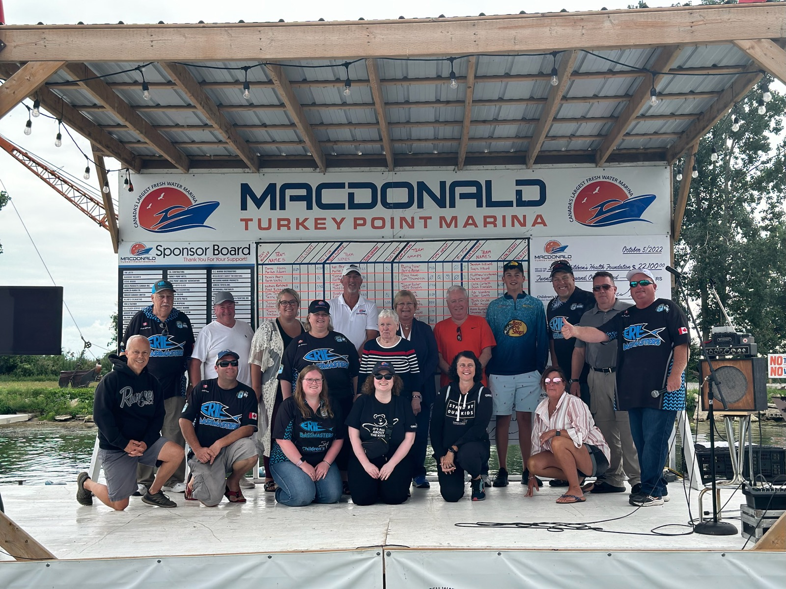  2024 Long Point Bay Bass Tournament  2nd Person ___________________________  Address __________________________________  _________________________________________  Prov/State __________________  Postal Code _________________  Phone ( _____)____________________  I have read, and understand the waiver on this entry.  Signature __________________________  1st Person ______________________________  Address ______________________________________  ______________________________________  Prov/State __________________  Postal Code _________________  Phone ( _____)____________________  I have read, and understand the waiver on this entry.  Signature ______________________________  - LOCATION: Tournament headquarters will be located at MacDonald Turkey Point Marina, Turkey Point, Ontario, (519) 426-6795  - ELIGIBILTY: All persons 16 years of age or over are eligible. Persons under that age are allowed to fish with a parent or guardian.  - TO ENTER: The entry form must be completed, signed, and sent with the appropriate fees, in Canadian funds, to the mailing address on the entry form.  - WEATHER DELAY DATE: If inclement weather prevents the tournament from taking place as scheduled, it will be rescheduled to the following Sunday.  - LIVE WELLS: Live wells with circulators will be mandatory for the keeping of fish and must be used.  - TARGET FISH: Largemouth and smallmouth bass are the only species eligible to be weighed in.  - EQUIPMENT: Only ONE rod per person may be used at any one time.  - BOUNDRIES: This applies to event competitor, no special privileges will be tolerated. Boundaries are waters of Long Point Inner Bay only (from MacDonald Turkey Point Marina to Pottahawk Point). No fishing east of the boundary line.  - COMPETITIORS MEETING: One team member will be required to attend the official competitors meeting, which will be open for registration at 7:00am, rules will follow. If you are registering on the Sunday morning please be at the meeting at 7:00 am, to avoid congestion. This meeting will be held at the Turkey Point Marina Gas Docks. You must contact the tournament committee if you will not be able to attend the meeting!  - LIFE JACKETS: All competitors must wear approved flotation devices while the main combustion engine is running.  - MEETING: Boat inspections will be random beginning at 7:00 a.m. that morning. All boats must report in with the tournament officials at the start.  - START: A trickle start will be in effect. Team #1 will leave first at 7:30 am.  - WEIGH-IN: Weigh–in will be at 3:00 p.m.  - CATCH: A maximum of five (5) bass may be weighed in at the end of the tournament day. A penalty of one (1) pound will be taken off total weight for a fish that is determined dead by the tournament judges. | Featuring Long Point Bay Anglers Association  LIVE RELEASE BOAT  FISHING FOR A CAUSE:    Our 23 year total is:  $224,632  For more information  about the tournament or  becoming a sponsor,  please contact Brad at:  brad@macdonaldmarine.com  www.mtpmarina.com  - LATE CHECKING: Contestants who are late checking in at the end of the day will be assessed a penalty of one (1) pound per minute late.  - A TIE: A tie for the tournament win, will be determined by a victory one (1) hour fish off with the heaviest one (1) bass winning after the hour.  - IDENTIFCATION: Each boat will receive a tag, which is to be returned at weigh–in.  - LURES: Artificial lures will be the only means of catching fish with the exception of pork rind only.  - BAIT: No live, preserved, or prepared bait of any kind allowed, with the exception of pork rind.  - ALCOHOL: Alcoholic beverages are prohibited from competitor boats and must not be consumed by participants during tournament hours.  - BOATS: No person other than the competitors and tournament officials shall be allowed in the participants’ boat during tournament hours.  - RULE INFRACTION: Competitors may be disqualified for any rule infraction without refund.  Each entrant upon registering to compete in the MacDonald Turkey Point Marina Bass Tournament agrees to hold MacDonald Turkey Point Marina Bass Tournament, and any or all the sponsors, officials, organizers, their employees, agents and all other competitors and non-competitors harmless from all liability of any nature or kind for any injuries and or damage suffered by the entrant, before, during or due to participation in the MacDonald Turkey Point Marina Bass Tournament. | 24th Annual  MACDONALD  TURKEY POINT  MARINA  London Children’s  Hospital  CHARITY BASS TOURNAMENT  Sunday, September 8th, 2024  Weather delay date  Sunday, September 15th, 2024  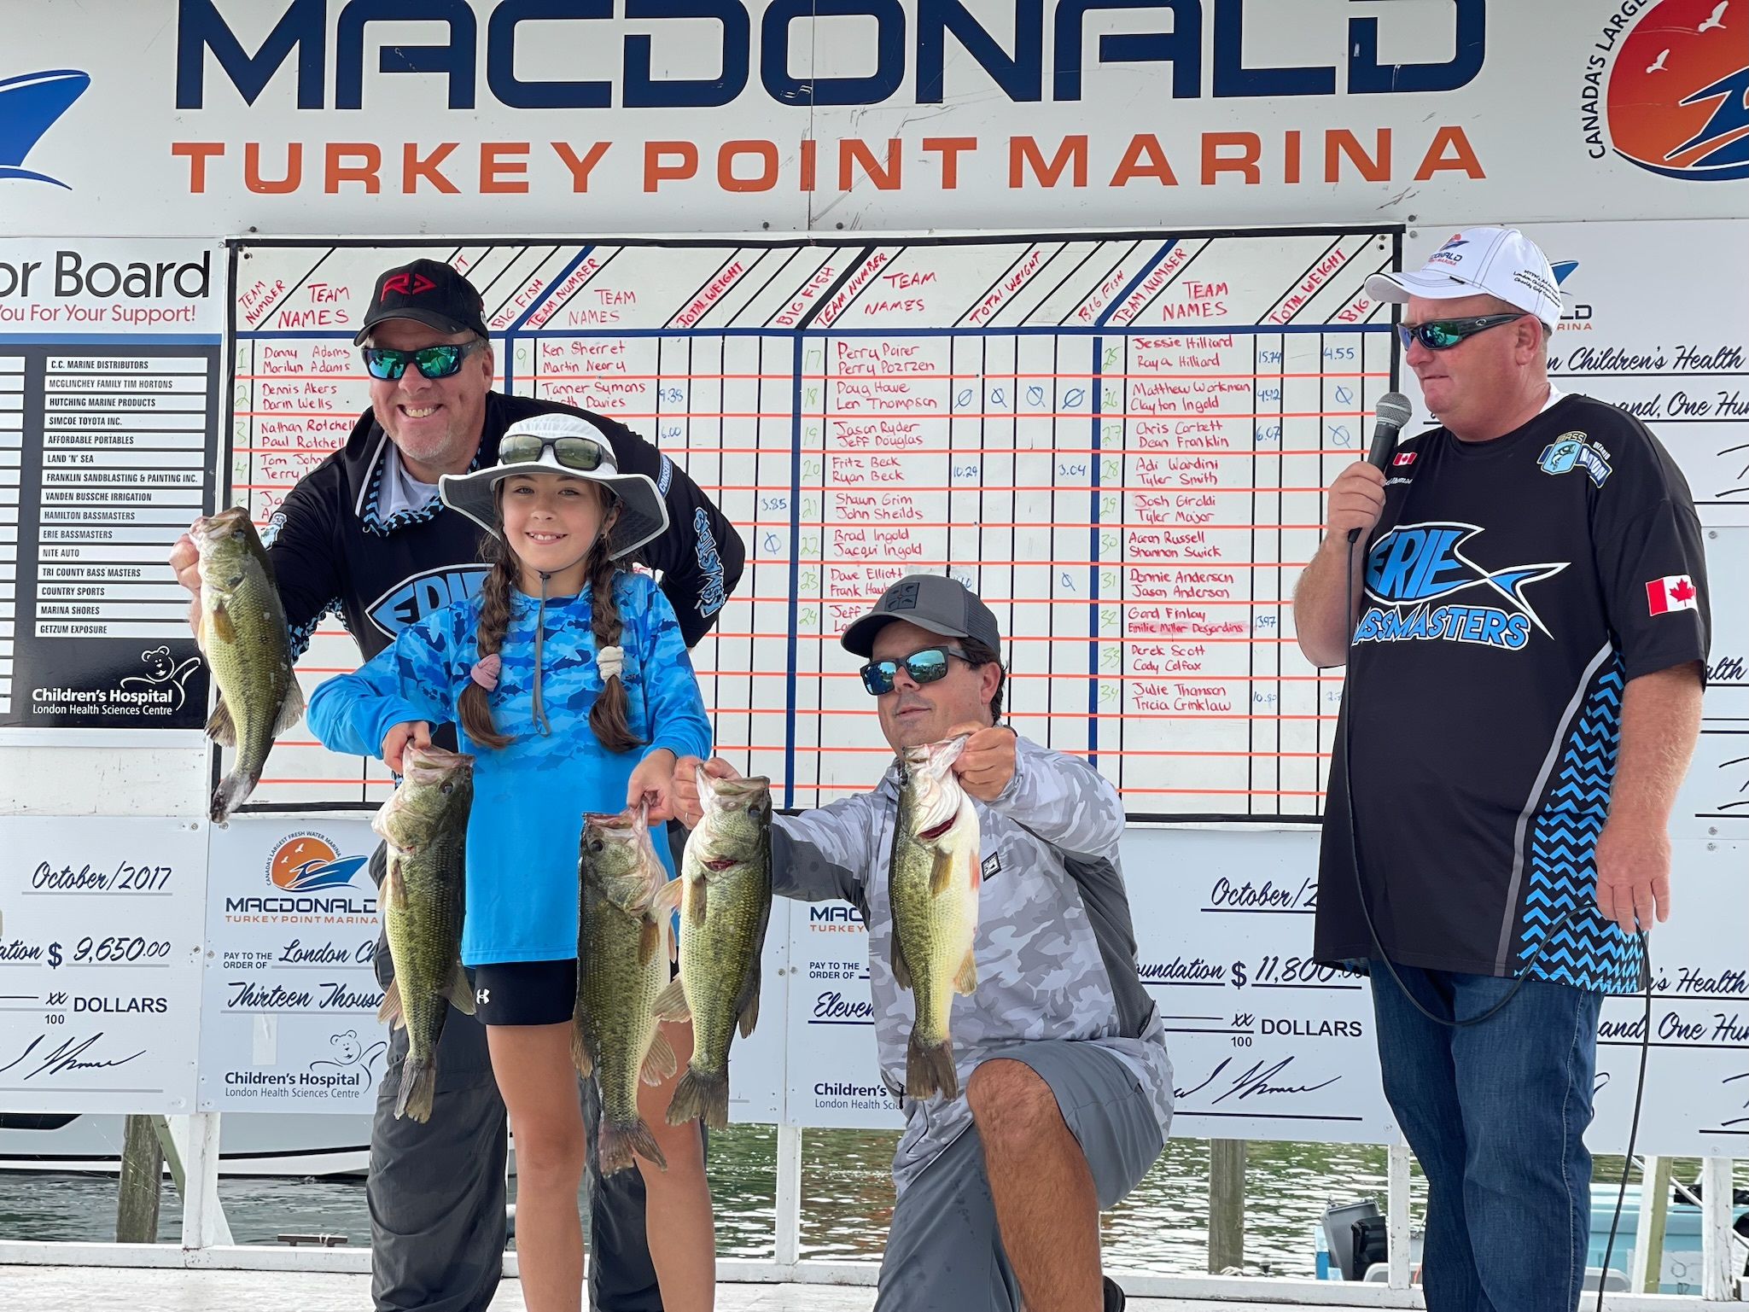  Experience the thrill of  Tournament Fishing,  for a cause  London Children’s Health Foundation  Entry Fee $200.00 Per Team  This includes $20.00 for Big Fish  With $80.00 going to the  London Children’s Health Foundation  Full Field is 50 teams  Please have payment in by  September 1st , 2024  Please send correct amount, in Canadian funds, cheque or money order, payable to:  CHWO Foundation Boat Draw  And Tournament  Or pay by e-transfer sent to  accounting@macdonaldmarine.com  Send entry form and payment to:  MacDonald Turkey Point Marina  92 Clubhouse Road, R.R.1  Vittoria, Ontario N0E 1W0  Phone: (519) 426-6795  Email: brad@macdonaldmarine.com

